Headteacher Recruitment Pack

April 2021

Welcome!
Dear Applicant,

I am delighted that you have expressed an interest in the role of Headteacher at Future Education, and I am pleased to share with you more information about our school and the role within this pack and in the Job Description.

The Governors recognize the school is on a journey of improvement, but that it has exceptional potential. You will be joining us at an exciting time as we are seeking a natural leader who can build upon our growing school and develop our students and staff further to ensure that all our students grow into happy and productive members of our community, confident in their values, skills and judgement.

Our aim is to engage children in learning, inspiring them to achieve, and nurturing them to become successful adults. As the Head of a relatively small school you will have significant scope for creativity and innovation when determining how the school operates, you will bring a strong vision and a drive to achieve change, and perhaps most importantly, you will have the opportunity to see first-hand the impact of the school’s work on the lives of our students and their families.

We expect you will have strong experience of leadership in an education setting and demonstrable track record of bringing about positive change and improved outcomes for students with SEND. You will have strong and articulate values, and be able to engage and involve children, staff, governors and parents in the maintenance and refreshment of the school’s strategic vision. You will also have the emotional resilience to lead others in what can be a demanding and fast-moving environment which requires strength, conviction and care.

More information on the role is contained in the Job Description and Person Specification, please consider those documents carefully when crafting your application.

Visits to the school are encouraged and can be organized by contacting the School Business Manager on 01603 250 505 or m.anderson@futureeducation.org.uk

Future Education is a fantastic place to work, equally challenging and rewarding. If you would like to play a leading role in our journey, I look forward to hearing from you!

Your sincerely,

Chair of Governors,
Daniel Childerhouse

Chair of Trustees
Mike Stonard

What our students say:

“All staff at every level, should be understanding & approachable”

“Therapeutic themselves, in their own interpersonal communication”

About Future Education
Commissioning and enrolment: Students are placed at Future Education on a child-by-child basis by Norfolk County Council having previously been excluded from mainstream, alternative or special education settings. Through this approach Future Education assesses each student to determine suitability and compatibility with the school’s aims, approach and curriculum. Risk assessments and careful planning are undertaken before any student is enrolled.

The School can accommodate up to 44 students, but enrolment is usually limited to 30-35 students for practical reasons. There is scope for future growth as we develop our services and reputation within the sector.

Ofsted Rating: The school’s current Ofsted rating is Requires Improvement. Following a monitoring visit in October 2019 the school has implemented an updated improvement plan. You can read the school’s inspection reports here: https://reports.ofsted.gov.uk/provider/27/135859

Student Profile: Future Education is an Independent Special School which works with boys and girls aged 13-16 who have experienced difficulties in accessing mainstream and who may have been excluded. All students require specialist teaching, facilities, resources and adult support.

Students in the school have learning difficulties which cover a wide range of needs and are likely to need support in all areas of the curriculum. Many of our students have difficulties with communication and challenging or unsafe behaviour which impacts on their learning and the way in which they engage.

All students have Education Health & Care Plans (EHCPs), and almost all have medical conditions such as anxiety, depression, agoraphobia, oppositional defiant disorder, and autistic spectrum disorders. Some students are Looked After Children and a high proportion have significant histories of childhood trauma and/or abuse. Many have been out of education for long periods prior to enrolment (sometimes years) and the safeguarding needs of the cohort are very high.

The nature of our school means that the likelihood of violent and aggressive behaviour from students is relatively high, and whilst the school has in place a comprehensive range of risk management and safety control measures it is not possible to completely eliminate such risks.

Curriculum: Future Education is committed to putting the needs of our students at the heart of our curriculum. We believe in providing a nurturing and supportive environment where students with diverse needs can re-engage with learning.

We recognise that how students learn is as important as what they learn. We believe that only through meaningful relationships of trust and understanding can we help students develop the wellbeing and confidence to learn and grow. Students therefore require a caring and therapeutic approach to education in order to re-engage with learning and build resilience.

The aim of our curriculum is that students:
- Become successful learners who value their achievements and reach their full potential.
- Are able to recognise and make positive, safe life choices.

The curriculum therefore is intended to:
- Promote re-engagement in education
- Provide a broad and balanced education for all students
- Be flexible to meet the diverse needs of students through learning pathways
- Build on existing knowledge, skills and understanding
- Challenge students to achieve their potential
- Reflect the multi-cultural nature of society and build on British Values
- Inspire learning through Cultural Capital.
- Develop confidence, respect, and wellbeing
- Enable students to remain healthy and safe from abuse, criminality, radicalisation and extremism
- Prepare students for the next steps in their journey
The curriculum is designed to ensure that all students have access to English and Maths as a mechanism to develop core literacy and numeracy skills in addition to Science, Humanities, PHSE, Art, ICT, Media. These subjects are core subjects accessed by all students on site at the school and provide the basis around which timetables are designed. Physical health is delivered one afternoon a week providing students with a carousel of sporting activities such as boxing, badminton, fishing, gym, football and personal training.
Alternative provision is sought where students identify particular interests in order to engage and develop a love of learning (cultural capital). Alternative provision provides the school with flexibility to meet student needs and aspirations through the commissioning of specialist training providers.
Organisation: Students are placed into mixed groups depending on their chosen subjects, with class sizes limited to approximately 5-6 students.
Some students have allocated Teaching Assistants to enable them to access the curriculum fully.
The school day is 8.45am to 2.30pm.
The school follows Norfolk County Council term time calendars and most staff work term time plus two weeks for INSET training, CPD and planning/preparation.
Therapeutic approach: as part of the whole-school therapeutic approach, Future Education integrates fully accredited and appropriately qualified psychological practitioners within the curriculum to support children to access learning, to develop important coping mechanisms, and to tackle tough issues in creative ways whilst learning. Provision currently includes: Speech and Language Therapy, Occupational Therapy, Psychotherapy and Nurture, Art for Wellbeing and Music Therapy.
Staffing: Students require significant adult support and as such the school has a relatively high staff-to-student ratio (c25:c35).
The staff structure is outlined in the chart overleaf.
The school’s leadership team is also supported by the charity’s core team where appropriate, including the CEO, Head of Operations, and Finance Manager.

Our Values
Organisational Values are the defining culture or guiding beliefs of an organisation – they dictate our behaviour and explain how we will go about our mission. It is important that we practice what we preach, so you can expect to see these values demonstrated in everything we do:

- Responsible: We act responsibly and hold ourselves to the highest standards in everything we do

- Dedicated: We are relentlessly dedicated to our mission, care deeply for our work and our beneficiaries, and do not give up

- Ambitious: We are demanding of ourselves and others; we set ambitious goals which push us and our beneficiaries to achieve more

- Listening: We build meaningful relationships with the communities we serve and others by listening, understanding, and working together

- Empowering: We are committed to empowering people to make sustainable change happen

- Creative: We are open to new ideas, embrace change, take considered risks, and seek creative ways of finding solutions to society’s problems

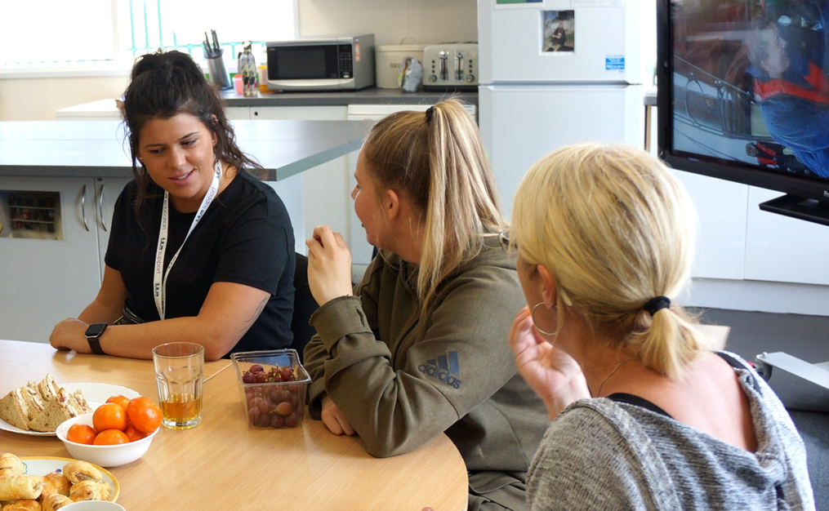

What our staff say:
“Future Education is a vibrant school to work at, there is never a dull moment. I find it particularly rewarding, supporting and encouraging students who have a range of differing needs and abilities to progress to be independent learners. I enjoy working as part of the team here at Future Education who are all supportive and experienced”

“Over the last twenty years I have been fortunate enough to have been part of Future Projects. The work we do has affected and touched many lives and the success of the Charity is down to the hard work and dedication of the staff and volunteers. I am very proud of what we have achieved over the years”

“Working at Future Education is unique and very special. Every day is different and brings its own challenges. Some days you have to be prepared to drop everything planned for that day and support a pupil. What you get in return is the satisfaction that your efforts will have made a difference to that young person and their family. You in turn will receive the support you need from the amazing staff team, an extended 'family' who will look after you and your needs. Everyone at Future Education has a voice and everyone is heard.”
“Why do I love working at Future Education? It is a supportive environment with skilled people who share the same passion for the wellbeing of our students. I feel incredibly privileged to be part of their journey.”

The application process: Please read the Job Description and complete the Application Form in full and submit via email to m.anderson@futureprojects.org.uk by 5pm on 3rd May 2021
The selection process will take place over the week commencing 10th May 2021 days and will consist of:
- Pre-interview Online Personality Test (with professional evaluation and feedback)
- Student Panel Interview
- Teaching, Learning and Behaviour Panel interview
- Leadership Panel Interview
- Safeguarding Panel Interview
- Candidate Presentation.
To arrange a visit (subject to the Covid-19 situation) or a conversation with the CEO/Chair of Governors please email m.anderson@futureeducation.org.uk

If you are shortlisted for interview you will hear from us by no later than 5th May 2021 at 5pm. Unfortunately, we may not be able to contact candidates who have been unsuccessful at the shortlisting stage.
Safeguarding: Future Education is committed to safeguarding children and adults and expects all staff and volunteers to share that commitment. Our primary concern is always the safety and wellbeing of children. The Children Act 1989 requires everyone working with children to inform Children’s Services about any child thought to be in need of support or at risk of harm.
The statutory guidance, Keeping Children Safe in Education DfE (2020) states schools should work with social care, the police, health services and other services to promote the welfare of children and protect them from harm. The Education Act 2002 requires all schools to have arrangement to safeguard the children. We have a range of policies and procedures to that effect. You may obtain a copy of the school’s safeguarding policies by contacting m.anderson@futureeducation.org.uk or checking the school’s website: Future Projects (futureeducation.org.uk)
The School’s Designated Safeguarding Lead is: J. Maclennan – Acting Headteacher: j.maclennan@futureeducation.org.uk or 01603 251 310
If you have concerns about the Acting Head Teacher, please contact the Chair of Governors, Daniel Childerhouse: d.childerhouse@futureprojects.org.uk or 01603 250 505.

